Thoracic mobilizing and core strengthening exercises

Before performing any of the stretches below please read the information sheet attached.

9. Upper Thoracic rounding 10. Mid and Lower Thoracic rounding
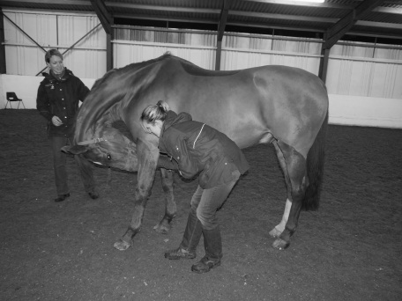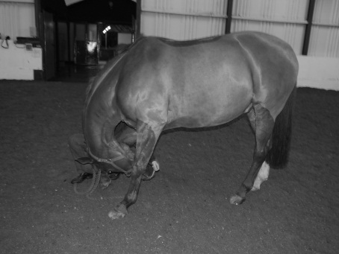
Aim to maintain a straight head position with no tilt. Entice chin in between elbows or to chest which will help flex the thoracic spine at the withers.

Aim to maintain a straight neck with no tilt. Entice nose between forelimb fetlocks and beyond. Once the neck is fully flexed, thoracic flexion will occur, mobilizing this region and also stimulating abdominal/core activation.

11. Thoracic lateral bending exercise 12. Thoracic rounding exercise
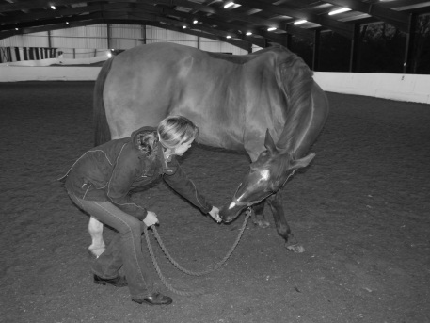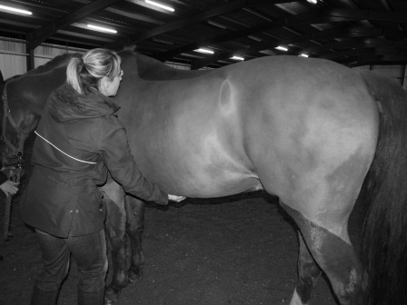
Run fingers along mid-point of sternum with an equal but firm pressure to encourage thoracic flexion and core activation. Please Take care as some horses can kick forwards with this.
Entice nose around towards hindlimb fetlock. This will laterally flex the thorax mobilizing this region and stimulate abdominal/core activation.

Property of Bridgefield Physiotherapy Ltd, not to be copied without permission ©

