Physiotherapy cervical/thoracic mobilizing and stretching exercises

Before performing any of the stretches below please read the information sheet attached.

1. Upper cervical Side flexion 2. Mid-cervical Side flexion
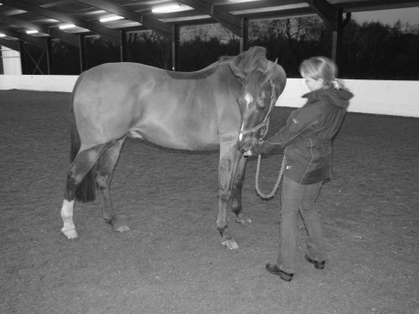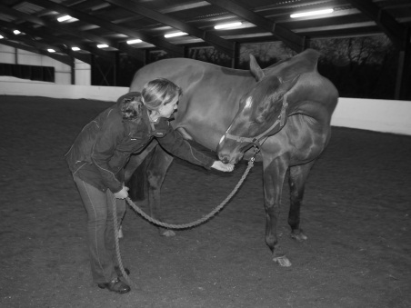
Aim to maintain the head in a vertical position and position nose in towards the point of the shoulder

Aim to maintain the head in a vertical position and position nose to opposite girth position

3. Lower cervical side flexion 4. Upper cervical (poll) and thoracic flexion
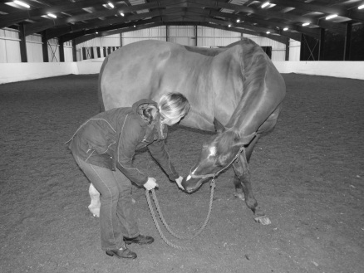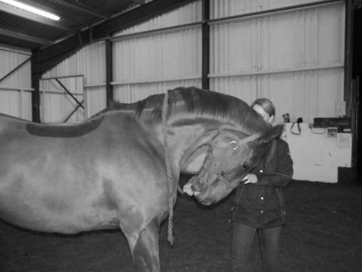
Aim to maintain a straight head position with no tilt and position chin in towards chest. Also activates deep neck flexor stability muscles.
Aim to position nose below stifle level aiming towards the hindlimb fetlock. Try to avoid too much head tilting.

5. Mid cervical flexion/Upper Thoracic flexion 6. Lower cervical flexion
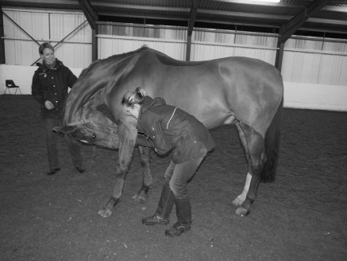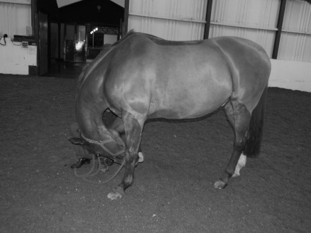
Aim to maintain a straight head position with no tilt and position nose between fetlocks, ideally maintain straight knees

Aim to maintain a straight head position with no tilt and position chin in between elbows.

7. Upper Cervical (Poll) Extension 8. Trick upper cervical (Poll) side flexion
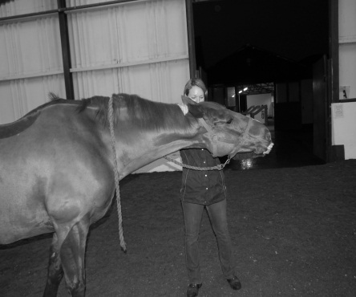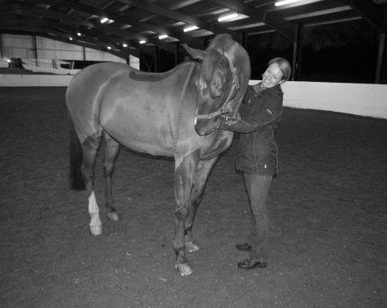
Stand on side to stretch/mobilise and reach under neck to tickle/scratch on opposite shoulder. Your horse may move quickly to your hand so be aware of your hand position!
Aim to maintain a straight head position with no tilt. Extend nose outwards whilst ensuring the horse remains still. Can be carried out over stable door.

Property of Bridgefield Physiotherapy Ltd, not to be copied without permission ©

