& 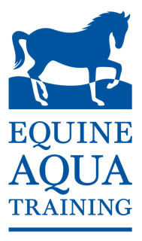
Invite you to a lecture evening
Kindly sponsored by
Tuesday 9th May at 7pm (demos start at 6.30pm)
Live demo of Aqua Icelander Water Trainer
Stand demonstrating new
Presentations
How training your horse on a water treadmill with and without incline can benefit performance
Maruska Aylward-Green MSc BSc MCSP HPC reg. ACPAT cat A
How straight are you?! Pilates for riders from a physiotherapy perspective
Cintia Low Gameiro MSc BSc MCSP HPC reg. ACPAT cat A
The pathway to injury (and possible prevention strategies!)
Jill Stone PG DIP, HNC, ITEC DIP, BHSAI
Presentation by Equitop Myoplasts
Please rsvp to office@bridgefieldphysio.co.uk or 01252821581 by Tuesday 2nd May.
Refreshments provided, minimum donation of £10pp, all profit to be donated to World Horse Welfare.

